- List 3 real-world devices in your home or college that use SMPS (Switched Mode Power Supply) and 2 devices that use UPS (Uninterruptible Power Supply), explaining in one line why each device needs that type of power supply.

- SMPS:
- Desktop Computer: It requires a very stable, low-voltage DC power supply for sensitive components like the motherboard and processor.
- LED TV: Its internal electrical circuitry requires a power supply that is free from voltage fluctuations.
- UPS:
- Computer Server: It requires an uninterrupted power backup to ensure that the server remains operational during a power outage, preventing the loss of critical data.
- Wi-Fi Router: It requires immediate backup power to ensure that internet and network connectivity in a home or college remains active without interruption during a power cut.

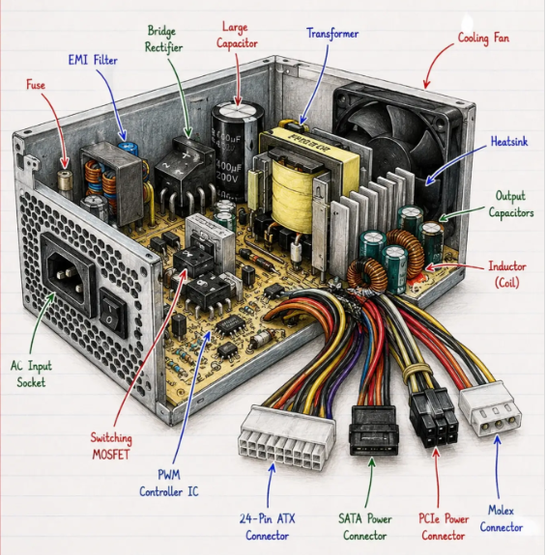
- Draw and label a diagram showing the main internal components of a typical SMPS unit found in a desktop PC, including AC input, rectifier, transformer, and DC output sections Hint You can hand-draw and upload a photo, or use any free diagram tool like draw.io

- Take photos or find clear images online of the following power connectors: ATX 24-pin motherboard connector, SATA power connector, Molex connector, and PCIe 6/8-pin connector. For each, write its name, the devices it powers, and one safety tip for connecting/disconnecting it.

- ATX 24-Pin Motherboard Connector
- Devices Powered: Main circuit board (Motherboard), logic circuits, and on-board components.
- Safety Tip: Always press down the plastic retention latch on the side of the connector before pulling, and hold the plastic shell rather than hugging the individual wires.
- SATA Power Connector
- Devices Powered: Modern internal storage drives like 2.5-inch / 3.5-inch Hard Disk Drives (HDDs) and Solid State Drives (SSDs), plus optical drives.
- Safety Tip: These flat L-shaped connectors are keyed to go in only one direction; never force or bend the thin plastic casing sideways when plugging or unplugging.
- Molex Connector
- Devices Powered: Legacy IDE storage drives, older optical drives, peripheral case fans, and specialized lighting or pump controllers.
- Safety Tip: Molex pins can stick tightly—wiggle the connector gently side-to-side while pulling rather than yanking the wires to avoid pulling the metal pins out of the plastic housing.
- PCIe 6/8-Pin Connector
- Devices Powered: Dedicated graphics cards (GPU) and expansion cards that require auxiliary power.
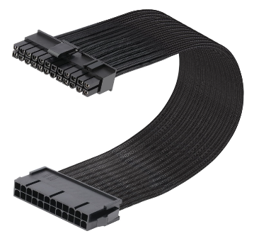
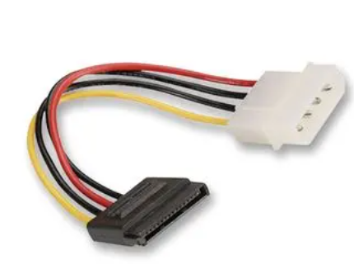
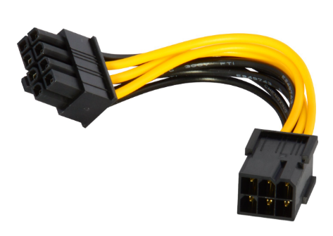
- Safety Tip: Make sure to release the tiny locking clip (and combine the detachable +2 pins properly if using a 6+2 configuration) before extracting it from the graphics card.
ATX 24-Pin Motherboard Connector
SATA Power Connector
PCle 6/8 –Pin Connector

- Imagine you are setting up a new gaming PC. List the steps you would follow to connect the SMPS to the motherboard, graphics card, and storage devices, mentioning which specific cables and connectors are used for each.

- Motherboard Connections:
- 24-pin ATX Cable: This is the primary cable from the SMPS. Connect it to the main 24-pin power slot on the motherboard.
- 8-pin (4+4) EPS Cable: This cable supplies power from the power supply to the CPU. Insert it into the appropriate slot located on the top-left side of the motherboard (as shown in the image).
- Graphics Card Connection (GPU Connection):
- 6+2 Pin PCIe Cable: This cable is used for standard graphics cards. Plug in either the 6-pin or 8-pin connector, depending on the GPU's requirements.
- 12VHPWR (16-Pin) Cable: If you have an advanced card, such as a newer NVidia RTX 40-series model, use this specific single cable.
- Connecting Storage Devices:
- SATA Power Cable: Connect this flat-shaped connector to the power port of a 2.5-inch SATA SSD or Hard Disk (HDD).
- M.2 NVMe SSD: If you are using this modern type of storage, there is no need to connect any cables from the SMPS. It draws power directly from the motherboard.

